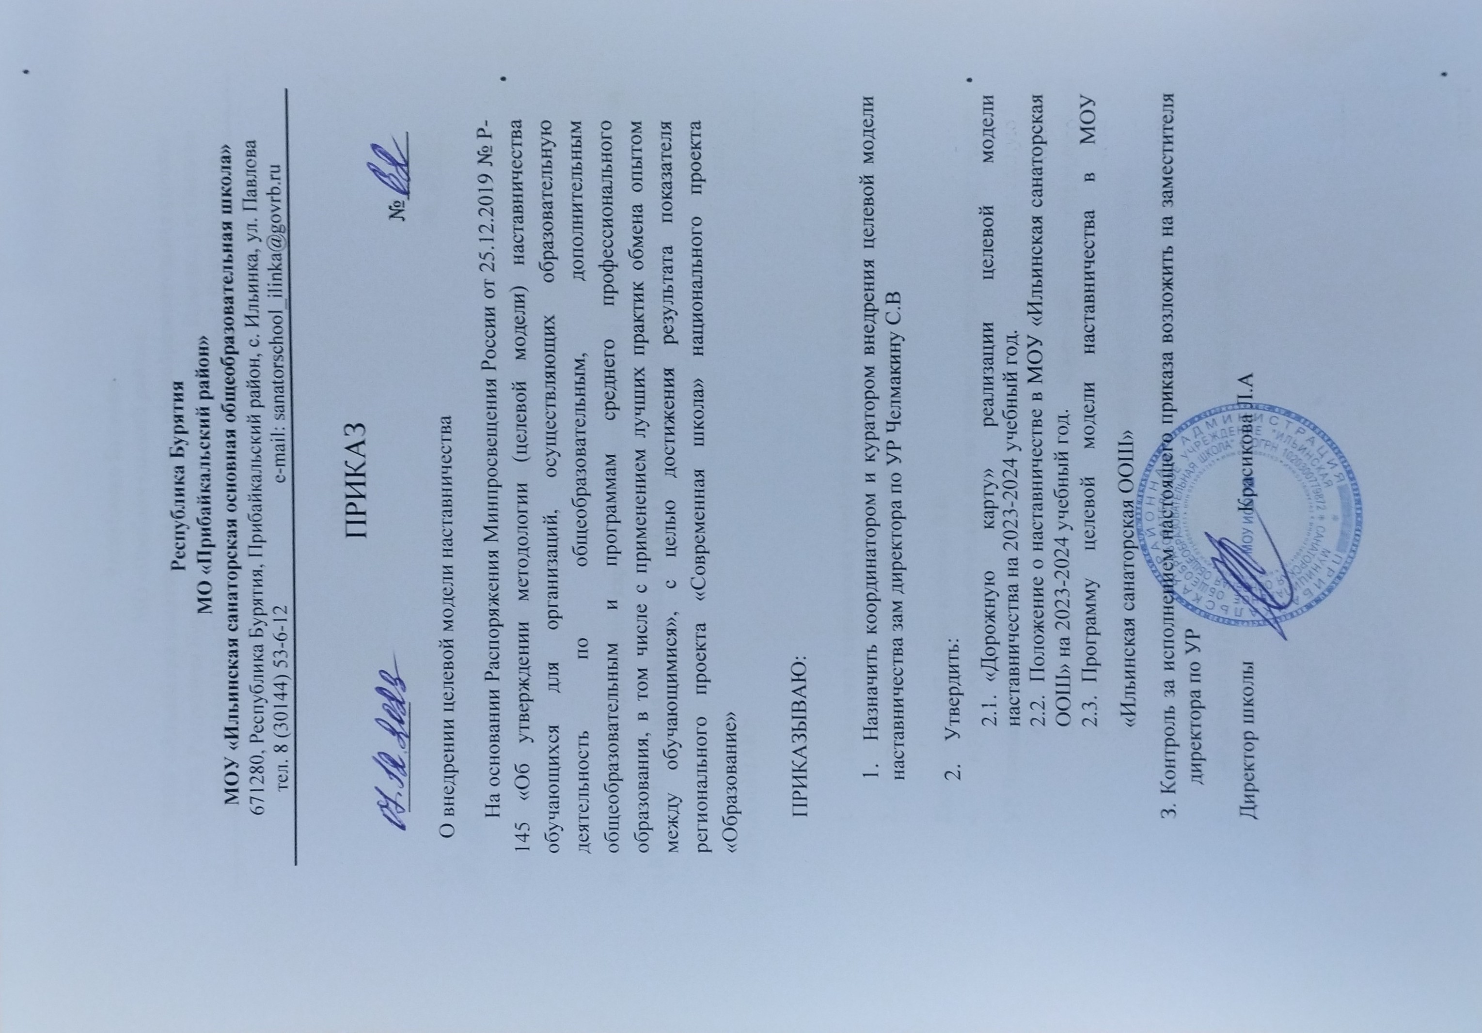
canned with AnyScanner Scanned with AnyScanner

